Assignment 2-Case Study

Stage 4 Lab Activities

Implementing the SmartCare Domain Layer
DESIGN FIRST -> AI PAIR PROGRAMMING -> REVIEW -> VERIFY | 1hour

A - Revisit Approved UML
Confirm responsibilities, attributes and relationships before coding.
- The approved model uses three main classes:
- Patient
- Practitioner
- Appointment
The relationship between the, ( Patient ‘1’---------‘0..’, Appointment ‘0..’-------- ‘1’, Practitioner ) this is proved by the UML Diagram
As follows, each appointment has exactly one patient and one practitioner, Appointments cannot overlap for the same practitioner, Cancelled appointments remain stored as objects

B - Implement Patient: AI OFF
Implement Patient with type hints and basic validation.

C - Implement Practitioner: AI OFF
Implement Practitioner with identifier, name and specialty; no database logic.

D - Implement Appointment: AI ON
Give AI the approved Appointment UML, business rules and explicit constraints. Ask it to implement only Appointment and agreed enum/exception.
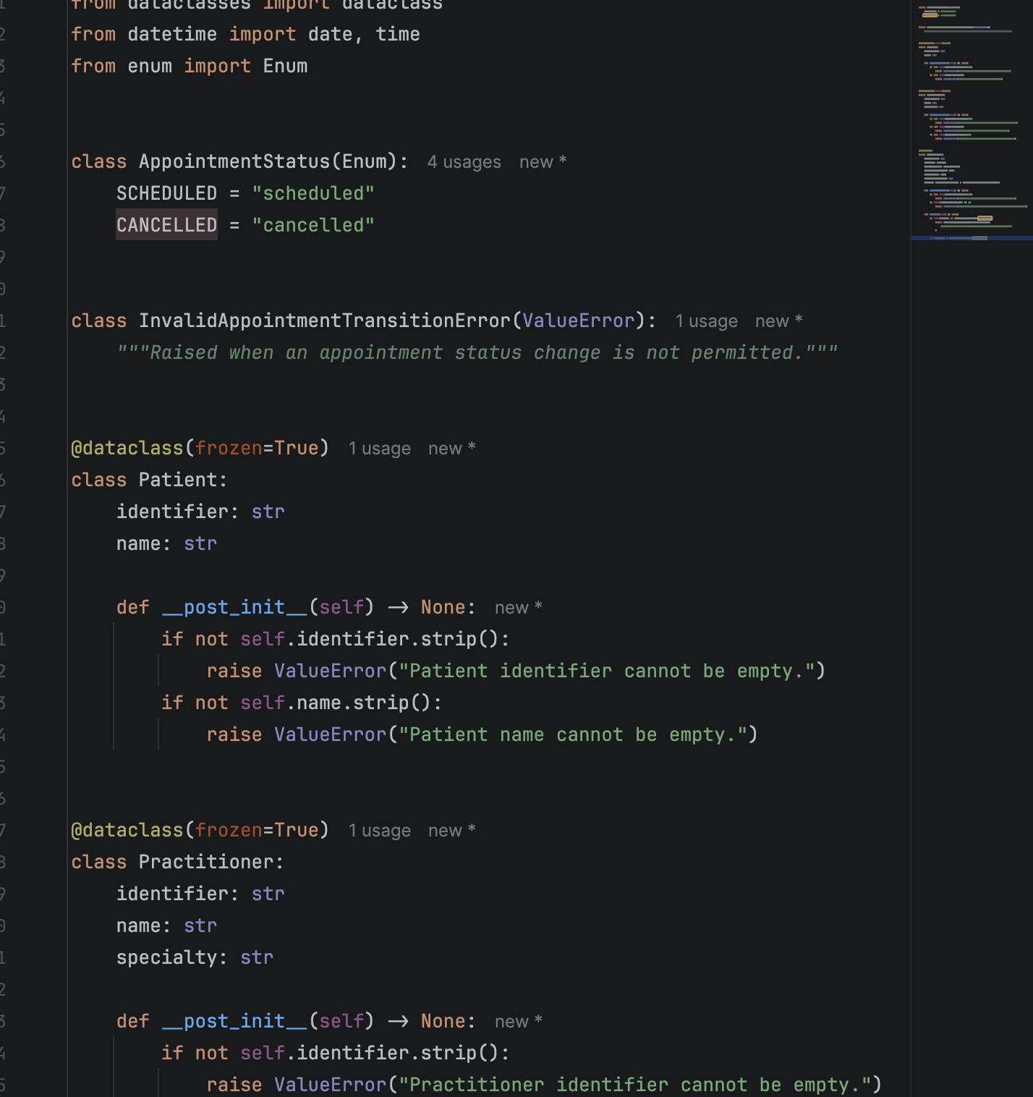

Solutions through (A-D)

E - Review Generated Code
Check model consistency, unsupported features, public state mutation, unnecessary inheritance, invented dependencies and error handling.
- The implementation is consistent with the approved UML:
- Patient contains only an identifier and name.
- Practitioner contains an identifier, name and specialty.
- Appointment references one Patient and one Practitioner.
- Appointment Status is an Enum, not an unnecessary class hierarchy.
- Cancelled appointments remain available as objects.
- No database, UI, notification, controller or service dependencies were added.
- Public state mutation is limited to the required status change through cancel.
- Invalid identifiers, names, specialties and durations raise clear Value Error exceptions.
- Repeated cancellation raises a specific transition exception.

F - Manual Behaviour Checks
Create valid objects, test invalid input, cancel a scheduled appointment and attempt an illegal repeated transition.
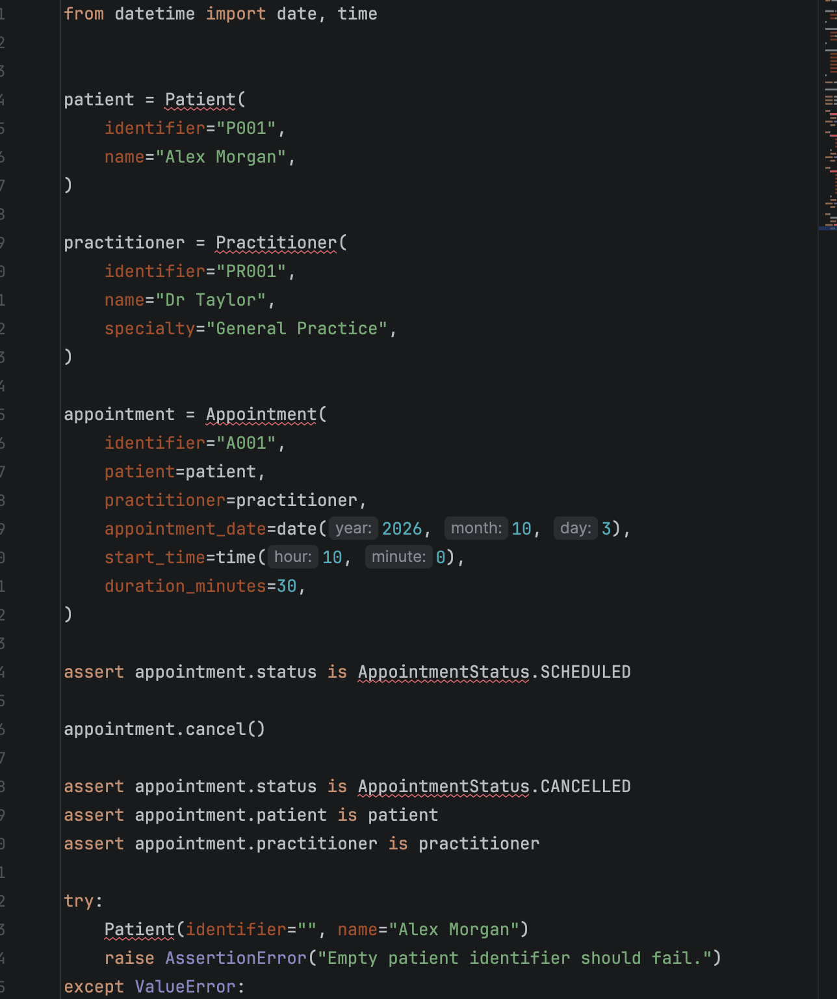
These Checks validate that valid objects can be created, invalid values are rejected, cacellation works, Cancelled objects remain available and repeated cancellation is illegal.

G - Refactor
Remove unnecessary code and make implementation simpler and design-consistent.
- No further refactoring is needed. The final implementation is small and matches the approved model.

H - AI Engineering Log
Record prompt, generated contribution, decisions and verification evidence.
Item | Record
Prompt | “Act as a Python pair programmer. Implement only the Appointment class from the approved SmartCare UML. Use type hints and an AppointmentStatus enum. Cancelled appointments remain as objects. Do not add database, UI, notification or service classes. Protect status transitions and explain any decision not directly visible in the UML.”
Generated contribution | Proposed the AppointmentStatus enum, Appointment class, cancellation operation and transition exception.
Accepted | Type hints, enum-based status, object references to Patient and Practitioner, and cancellation without deletion.
Modified | Added validation to all three classes and used a specific InvalidAppointmentTransitionError for repeated cancellation.
Rejected | Database logic, UI classes, notification features, service classes, inheritance and unsupported scheduling dependencies.
Verification evidence | Valid construction succeeded; empty identifiers and names failed; invalid specialty and duration failed; cancellation changed status; repeated cancellation raised the expected exception.

Suggested AI prompt
Act as a Python pair programmer. Implement only the Appointment class from the approved SmartCare UML. Use type hints and an AppointmentStatus enum. Cancelled appointments remain as objects. Do not add database, UI, notification or service classes. Protect status transitions and explain any decision not directly visible in the UML.

Reflection
Which AI-generated part did you modify or reject? Why? How did the approved design constrain the AI?
- The main modified AI-generated part was the validation and error handling. It was tightened to reject blank identifiers, names and specialties, and to reject non-positive durations.
- The approved design constrained the AI by requiring only three core domain classes, exact relationships, an enum for status, and no additional infrastructure. This prevented unsupported additions such as databases, controllers, notification managers and service layers.

Even if it’s a simple project to get started, I believe the AI is Correct in terms of the unsupported additions, for instance if we are studying for a specific role, then this basic additions would be necessary for building a system.

